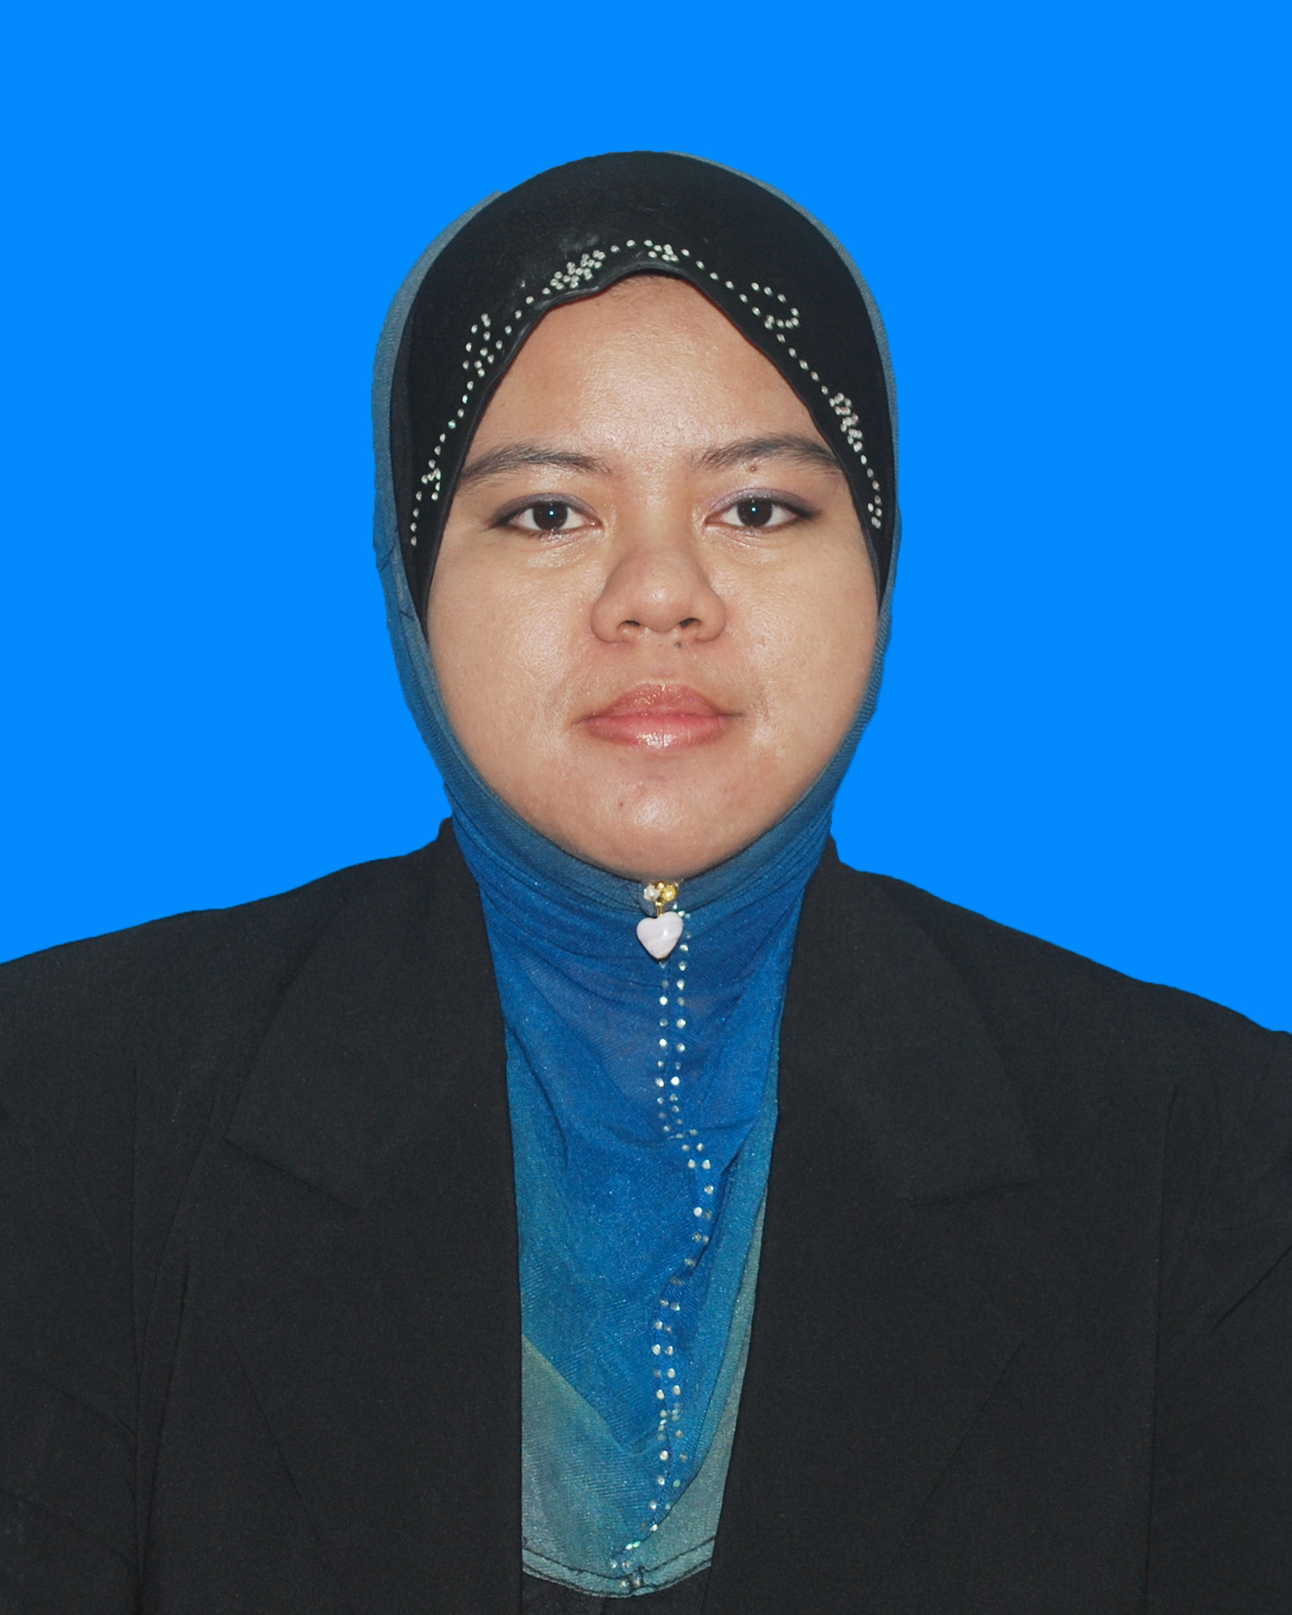
NURASYIKIN BINTI ALIAS@MINGAN

No 7, Jalan Kembojasari 1,
Bandar Sungai Buaya,
48010 Rawang Selangor

Telephone: (013) 7100237
E-mail: syikin.alias88@yahoo.com

Personal Information

Date of Birth : 1 August 1988 Nationality : Malaysian
Gender : Female Marital Status : Married
Identity Card No: 880801-23-5976 Health : Excellent
Interest : Playing badminton, watching television and reading.

Education Background

1. Level : Bachelor In Construction Management (Hons.)
Field of Study : Construction Management
Name Of Institution : Universiti Teknologi MARA ( Kampus Shah Alam)
CGPA : 2.53
Graduation : 2012

2. Level : Diploma in Building
Field of Study : Building Construction
Name Of Institution : Universiti Teknologi MARA ( Kampus Sri Iskandar, Perak)
CGPA : 2.87
Graduation : 2010

3. Level : Sijil Pendidikan Malaysia ( SPM )
Field of Study : Sains Reka Cipta
Name of Institution : Sekolah Menengah Air Tawar
Graduation : 2005
Grade : 4A, 3B, 2C, 2D
Work Experience

April 2012-5th November 2012 Clerk of work at TNC Consolidated
- Responsible to do inspection for structural work (beam, column, floor slab, and pile cap).
- Check the result of cube test and slump test.
- As monitoring for piling work and doing inspection for PILE DRIVING ANALYSIS (PDA TEST) after piling have done.
- Make sure the result of pressure test will be done by sub-contractor for every house

Reason leave : To move to the other carrier and to gain another experience

December 2012- September 2013 Assistant Quantity Surveyor at Lifatt Plumbing & Building
Contractor
- Progress Claim and estimation work for Water reticulation Work
- Prepare Tendering process and Quotation.
- Prepare Handing over document including PJB1
Form, chlorine test, and pressure test result
- Prepare progress report for every 2 week for all projects including total work done, work programed and progress picture.
- Attend meeting with Client or Developer

Reason leave : To move to the other carrier and to gain another experience

September 2013- August 2014 Assistant Quantity Surveyor at Qul Corporation Sdn Bhd

- Prepare Tendering process and Quotation
- Progress Claim, payment from client and estimation work.
- Prepare progress report for all projects including total work done, work programed and progress picture.
- Handle purchasing work including Purchase Order, price negotiable, to appoint sub-contractor in site.
- Manage site visit and discussed with project coordinator about project planning before started the project (included material use, costing and time management and detail report progress on going project).

Reason leave : GET A BETTER OFFER

August 2014- Present Project Coordinator at TRUE LIGHT M&E SDN BHD

- Prepare monthly Salary and Claim
- Arrange all documentation for project
- Apply and assist in handle foreign workers related issue (including worker attendance, and etc)
- Manage staff welfare i.e. medical, leave etc
- Check Site Dairy report and report for outstanding work.
- Manage patty cash claim (prepare payment voucher)
- Assist HR department to prepare worker Advance and salary ( included calculate salary of worker)
- Prepare worker permit, fomema, calling visa (VDR), check out memo & etc
- Prepare contract aggreement for worker
- Handle TNB FORM and make sure site has been workdone during submission ( must be attend site visit)
- Coordinate with other contractor if any related issue.
- Ensure that work progress follow work program / schedule
- Site visit and check site condition.

Reason leave : To move to the other carrier and to gain another experience

Skills / Strengths

Computer Skills:

- MS Office (Word / Excel / Power Point / Access) Excellent
- Internet Explorer Excellent
- Microsoft Project Beginner

Language Proficiency:

Languages – Proficiency Spoken Written

- Bahasa Malaysia Fluent Fluent
- English Intermediate Intermediate

- Full clean driving license ( D )
- Willingness to learn new knowledge
- Time management skills
- Able to work in a team or group environment
References

Text Resume

1. Hairudin Bin Md Salleh
Project Coordinator At Qul Corporation Sdn Bhd
No 14B(3) Jalan Tun Habab
81900 Kota Tinggi Johor
Tel:07-8826143
2. Miss Wah Li Jen
Human Resources at TRUE LIGHT M&E SDN BHD
No 29A Jalan Teratai 10,
81100 Taman Johor Jaya,
Johor Bahru, Johor
Tel:07-3351035

